Business Process:

Contact
Business Process Owner | Billing Operations
Subject Matter Expert(s) | Jhoan Funez, Katherine Martinez
Key Contact | Maya Duarte
Key Role | CSRs, Revenue Analysts, Strategic Account Advisors, Business Technology Analysts, Enterprise Technology Analysts
Date Created | November 1, 2016

Business Process Overview
The CeBill process is a partnership between SMUD, various commercial customers and a third-party payment vendor named CASS information system (an invoice paying agent). Commercial SMUD customers have the option to enroll in CeBill directly through SMUD, however sometimes CASS contracts with our customers to manage their bill invoices/payments.

Business Process Assumptions, Prerequisites, Dependencies
(Assumptions pertaining to the business process)
People | - Strategic Account Advisors  - Billing Solutions CSR, Sr CSR, Revenue Analyst  - COS Business Technology Analyst  - IT Enterprise Technology Analyst
Process | - CeBilling remains available to Commercial customers  - CASS remains the 3rd party biller for CeBilling  - The customer must request to be on electronic billing  - The account must be on a commercial rate
Technology | - SAP, Service Now

Process Flowchart
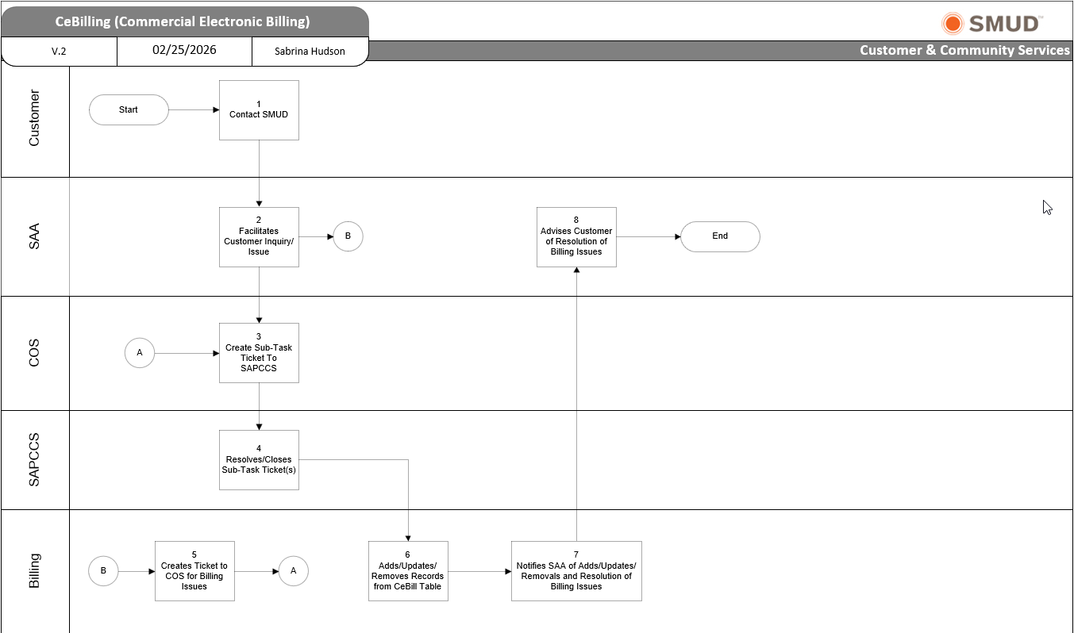

Task Description
Id | Task Description | Procedure
1 | Contact SMUD | - Customer contacts SMUD via phone or email
2 | Facilitate Customer Inquiry/Issue | - SAA Gathers information to determine next steps  - SAA Creates Service Now Ticket  - SAA Emails Billing Commercial Inbox
3 | Create Sub-Task Ticket to SAPCCS | - COS assigns Service Now tickets to a BTA and creates a sub-task ticket to SAPCCS
4 | Resolves/Closes Sub-Task Ticket(s) | - SAPCCS resolves/closes sub-task ticket(s) for Billing Issues and New Enrollments
5 | Creates Ticket To COS | - Billing creates Service Now Ticket for Billing Issues to COS
6 | Adds/Updates/Removes Records from CeBill Table | - Billing adds/updates/removes records from CeBill table using SAP transaction ZCS_CB_CA
7 | Notifies SAA of Adds/Updates/Removals and Resolution of Billing Issues | - Billing notifies SAA of records added, updated, removed from CeBill table, and resolution of billing issues
8 | Advise Customer Resolution of Billing Issues | - SAA Advises customer of resolution of billing issues

Business Rules
Id | Event Name | Business Rules
2 | Facilitate Customer Inquiry/Issue | - Open to commercial customers already set up on the program or to new customers enrollments  - SAA will create a ServiceNow ticket for new customer requests to be on program  - A Master BP is not required to enroll
6 | Adds/Updates/Removes Records from CeBill Table | - CASS/COMCAST account(s) should always have the paper bill suppressed and the address updated  - The customer record in the CeBill table must be end dated, so the CeBill code no longer displays on the ZCSBH screen  - A customer could no longer be an active CeBill participant, but the CeBill code will still show if not end dated in the table  - Never delete a CeBill record unless the wrong CA# used

Event | Legal Requirements, Rules, and Regulations  Legal documents/ procedures/ requirements to be fulfilled before/at the specified event.
Id | Event | Legal Requirements, Rules and/or Regulations
N/A | N/A | N/A

Pain Points and Improvement Opportunities
- Not having a mass tool to update the BP disp. Ctrl under the dunning correspondence

Departments impacted by process change (Required)

Department | Type of Change(s) | Action Required
Billing
IT: Customer - SAPCCS
Customer Operations Support (COS)

Supporting Documentation
(Any subsequent documentation in support of this business process (i.e. business requirements, technical specs, etc.) shall be summarized in the following table.)
Document Type | Link
Process Flow | CeBilling.vsd
Process and Procedure | CeBilling

Business Blueprint Amendments

Any subsequent changes to this business process blueprint after the official document approval shall be summarized in the following table. This document must be reprinted and signed by the authorized representatives.
Version | Author | Description of Change | Approval (Name/Sign) | Date
v.0 | Alicia Lopez | Document the as-is process |  | 11/1/2016
v.1 | Alicia Lopez | Update Support team from BPS to PDS |  | 12/19/2017
v.2 | Sabrina Hudson | Updates to contact info, process flows, process steps, and business rules |  | 7/25/2025
v.3 | Sabrina Hudson | Use of new template, updates to process flow and process steps, update contacts |  | 2/25/2026

